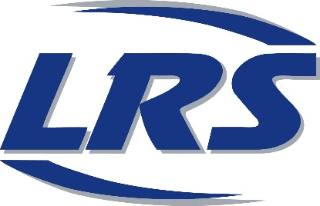
Town of Plymouth
Website: www.wisconsin.LRSrecycles.com
Email: Bltownservice@LRSrecycles.com
Phone: 608-580-0580

Garbage will be collected weekly. Recycling will be collected every other week.
Days in BLUE are your garbage and recycling weeks. Days in GREY are your garbage only weeks.
Holidays on a weekday: Service will be delayed one day.

Totes must be curbside by 6:00 AM

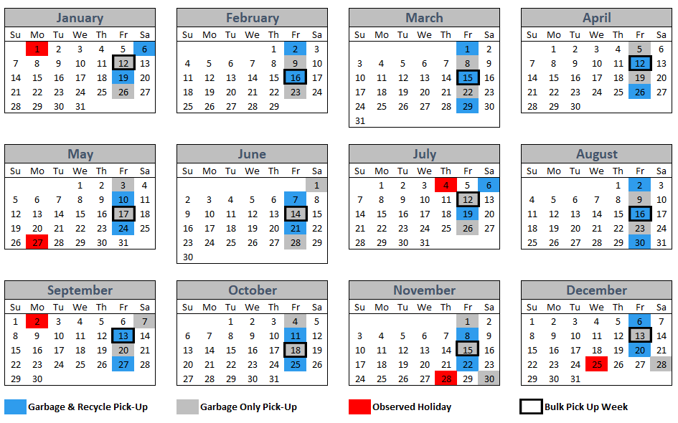
Service Day: Friday

Bulk Pick-Up Policy: You are allowed ONE bulk item per month on your designated day (Items NOT applicable: tires, appliances, electronics batteries, waste oil, waste liquids, or yard waste). Please call to schedule bulk item(s) at least 48 hours in advance 608-580-0580 or email bltownservice@LRSrecycles.com. All item(s) must be <50lbs and manageable by 1 person to ensure collection.

